**Intermolecular Forces**

The **more electronegative atom attracts the electron(s) more strongly**. A **slightly negative pole** forms at that end of the bond and a **slightly positive pole** at the other end. This is known as a **bond dipole** or **polar moment**.

The **greater the difference in electronegativity** between the 2 atoms the **greater the size of the dipole** and the **greater the strength of the dipole moment**.

Although the strength of a dipole moment increases with the increased difference in electronegativities between the atoms in the molecule, the dispersion forces become more significant with increasing number of electrons (molecular size). This adds to the intermolecular forces and increases the melting and boiling points.

A molecule with multiple polar bonds may or may not be polar. It’s dependent on the size and position of the polar bonds.

Vector sum (**size and direction**) of individual bond dipoles **give net force → polar molecule**.

Vector sum (**size and direction**) of individual bond dipoles **doesn’t give net force → non-polar molecule**.

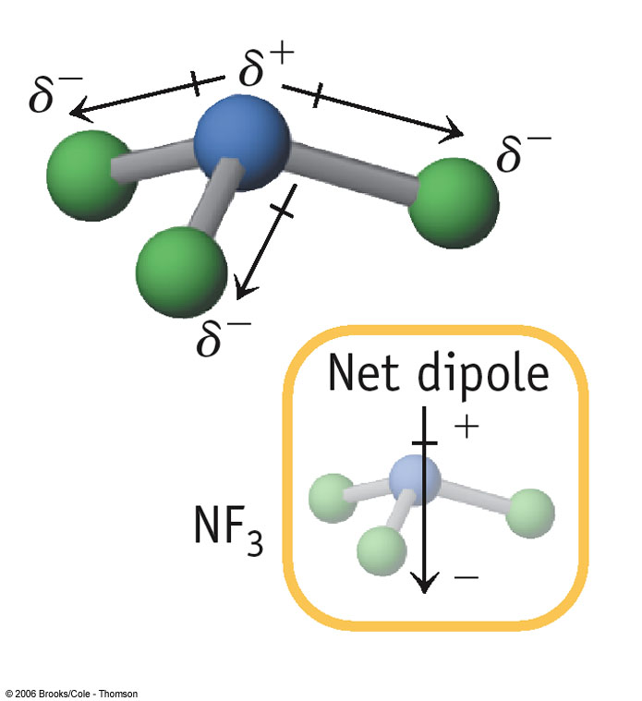

**NF3**

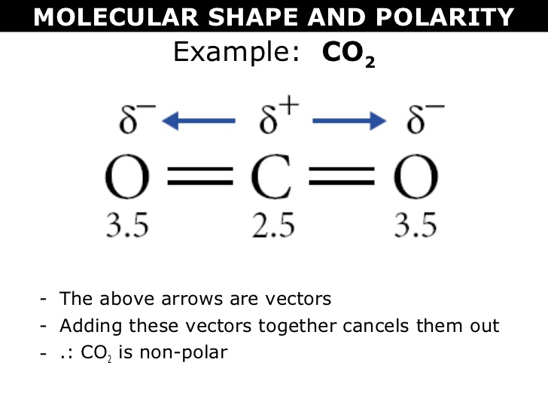

**CO2**



**No net dipole**

Intramolecular forces: The forces present within a molecule (covalent bonds). They’re much stronger than intermolecular forces (as are ionic and metallic bonds).

Intermolecular forces: The forces present between molecules. They’re much weaker than intamolecular forces and can be used to explain variations in melting and boiling points, vapour pressure and solubility.

Dispersion forces occur in all molecules but are most significant in **non-polar molecules** and **monatomic gases**. They’re **due to temporary dipoles** which result from the **random motion of shared valence electrons which aren’t symmetrically shared**.

The temporary dipole can then **induce temporary dipoles in nearby molecules**. These dipoles then experience **dispersion forces** – weak electrostatic attractive forces. They’re constantly appearing and disappearing and then reappearing somewhere else.

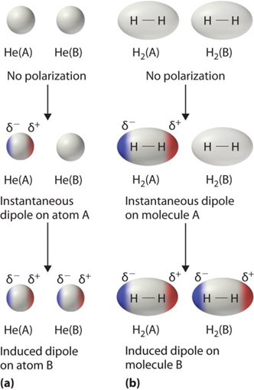

The **greater the dispersion forces** the **greater the melting and boiling points**.

The **greater the dispersion forces** the **smaller the vapour pressure**.

For molecules of similar mass, the **greater the surface contact between molecules** the **greater the dispersion forces** – **linear molecules** experience **greater forces than branched or cyclical analogues**.

**Dipole-dipole forces occur in polar molecules** and are **due to the electrostatic attraction between oppositely charged ends of the overall dipole**.

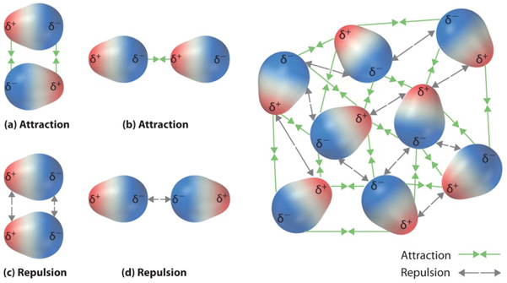

(Larsen n.d.)

Hydrogen bonding is an **extreme form of dipole-dipole forces** which only occur when a **hydrogen atom bonded to a nitrogen, oxygen or fluorine interacts** with a **non-bonding pair of electrons on another nitrogen, oxygen or fluorine atom** (either on the same molecule or from different polar molecules).

Hydrogen bonding is **due to the highly electronegative nature of nitrogen, oxygen and fluorine** that have a **high charge density** due to their relatively small size.

Melting and boiling points of **hydrogen bonded substances** tend to be much **higher** than those of substances of similar molecular size that display **only dipole-dipole or dispersion forces**. **Water** has the **highest melting point** as its molecular arrangement allows each water molecule to form up to **4 hydrogen bonds** whilst HF and others generally form less.

A solute will be soluble in a solvent if the solute-solvent intermolecular forces are of similar strength (or stronger) to the solute-solute intermolecular forces and to the solvent-solvent intermolecular forces.

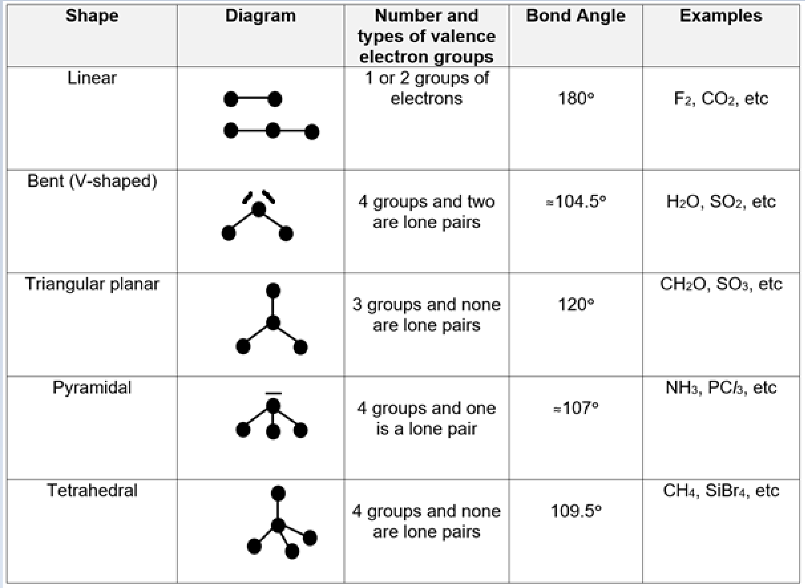

**Chromatography**

* The mixture is placed into a **mobile phase** (liquid solvent or gas stream).
* The mobile phase containing the mixture is **passed over a stationary phase**.
* The different components in the mixture **adsorb to the stationary phase at different points in time** depending on the nature of the stationary phase and the analytes in the mixture.

**Thin Layer Chromatography (TLC)**

* A **thin glass plate is finely coated with fine alumina (Al2O3) or silica (SiO2)** which acts as the **stationary phase**.
* The **mobile phase is a solvent** that will **dissolve and separate the components of the mixture**. The mobile phase moves up the stationary phase by capillary action.
* The TLC plate and solvent are placed in a **sealed container** to ensure the **vapour phase is saturated with gaseous solvent particles** and to **prevent the solvent evaporating**.

The analytes are carried up the stationary phase at different points and adsorb at different points **due to the difference in polarity of the analytes**. The **components** in the mixture can be **identified by their retardation factor (Rf)**.

**Rf =**

In TLC, the **retardation factor** of a given substance **depends on the nature of the stationary and mobile phases** and hence **isn’t constant**. For this reason, a **TLC of the different pure substances thought to be present in the mixture needs to be produced under identical conditions to obtain comparable Rf values**.

**Gas Chromatography (GC)**

* Used to identify individual, relatively **small molar mass** analytes which are **stable when heated** and their **concentrations** in complex mixtures.
* The **mobile phase is an inert carrier gas** e.g., He or N2.
* The **stationary phase is a high boiling point non-volatile viscous liquid adsorbed onto solid particles** e.g., silica. This is **packed within a long stainless steel coiled column**.

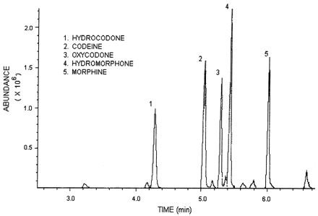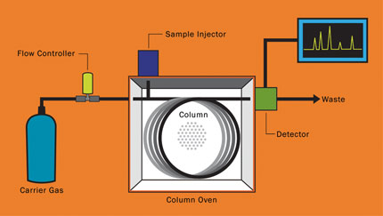

* This gas chromatograph consists of a: – Gas supply.
* High temperature injection chamber.
* Column.
* Detector.
* Recorder.

1. The liquid mixture to be anaysed is **injected through a rubber seal and vapourised**.
2. The vapourised mixture then travels **through the temperature-controlled column**. The analytes **remain either in the mobile phase or stationary phase** **based on their volatility** – tendency to evaporate.
3. Analytes with a **higher volatility** tend to **remain in the mobile phase**. These **exit** (are eluted from) the column **quickly** and have a **smaller retention time**.

The analytes can be identified by producing a chromatogram of the pure analyte under the

same conditions of: – Column choice.

– Carrier gas.

– Gas flow rate.

– Temperature.

**Analyte concentrations** can be determined from the **height and area of a chromatogram peak** when **compared to the peaks produced from a set of standards**.

**High Performance Liquid Chromatography (HPLC)**

* Used to identify individual, relatively **large molar mass** analytes which are **unstable when heated** and their **concentrations** in complex mixtures.
* The **mobile phase is a non-polar liquid solvent**.
* The **stationary phase is made up of fine particles** e.g., SiO2 that are **polar**. This is **packed within a short stainless-steel coiled column**.
* In **reverse phase HPLC**, the **stationary phase is non-polar** and the **mobile phase is polar**.

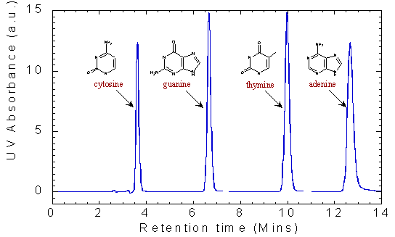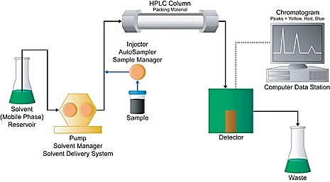

* The high performance liquid chromatograph consists of a: – High pressure pump.
  + - Sample injection loop.
    - Column.
    - Detector.
    - Recorder.

1. The liquid mixture to be analysed is **injected through an injection loop into a high-pressure column of solvent**. The sample then **travels through the column**.
2. The analytes travel at **different rates through the stationary phase based on their polarity**.
3. Analytes with a **higher polarity** tend to **adsorb onto the stationary phase**. These take **longer to travel through the column** and have a **larger retention time**.

The analytes can be identified by producing a chromatogram of the pure analyte under the

same conditions of: – Column choice.

– Mobile solvent.

– Solvent flow rate.

**Analyte concentrations** can be determined from the **height and area of a chromatogram peak** when **compared to the peaks produced from a set of standards**.

**Gases**

* For different gases at the same temperature, as they possess different masses, the **velocities of the particles differ**.
* The **greater the temperature of the gas**, the **greater the velocity of the particles**.

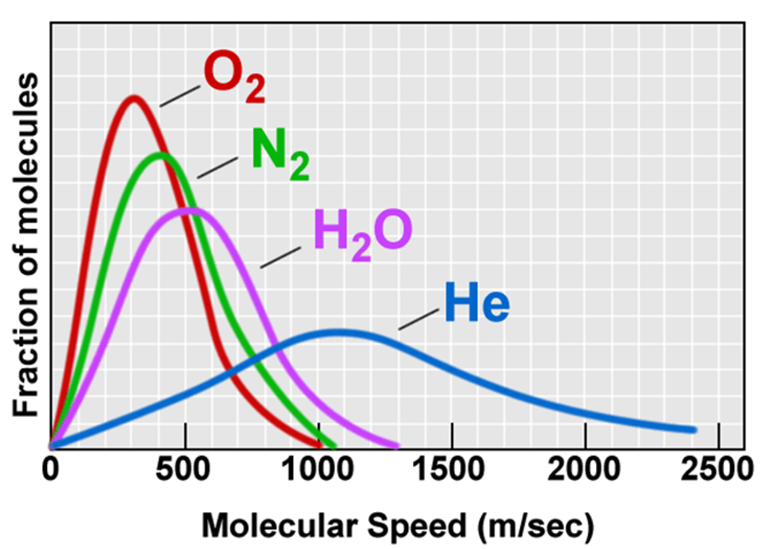

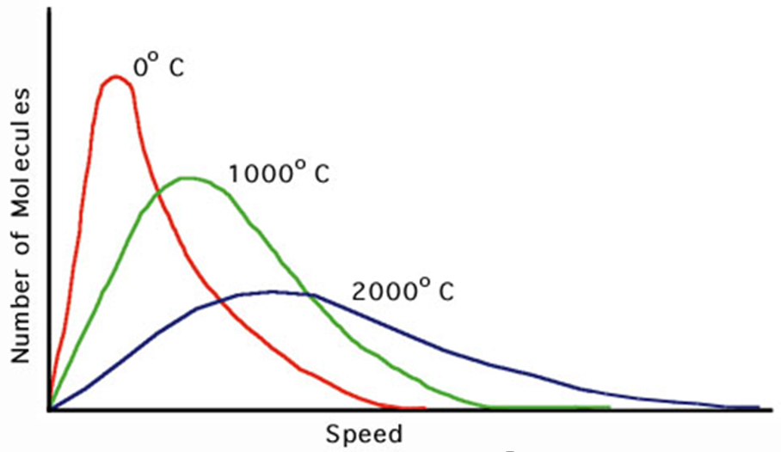

Physical properties of gases:

* Gases **diffuse** – due to their **rapid, random, straight-lined motion** and **negligible forces of attraction or repulsion** between them.
* Gases are **compressible** – due to the very **large space** between the particles and the particles having **negligible volume** themselves.
* Gases **take the shape of their container they’re in** – due to their **rapid, random, straight-lined motion** and **negligible forces of attraction or repulsion** between them.
* Gases have a **low density** – due to the very **large space** between the particles.
* Gases **exert pressure** – due to their **rapid, random, straight-lined motion** causing the particles to **collide with the container walls**; pressure increases with increasing **force and frequency** of these collisions.

Real gases differ from an ideal gas in that real gases:

* **Exert forces of attraction and repulsion**.
* **Occupy volume** which **can be significant when compared to the volume of the gas as a whole**.

Real gases approach ideal gases under the conditions of **high temperature** and **low pressure**.

Charles’ law: At **constant pressure**, the **volume** of a fixed quantity of gas **∝ temperature**.

Explained using kinetic theory: In a fixed quantity of gas, if you **increase the temperature**, the **pressure will increase** because the **gas particles gain kinetic energy and begin moving faster, hitting the container walls more often**. In order to maintain a constant pressure, the **volume must be increased** so that the **gas particles have further to travel before hitting the container walls**.

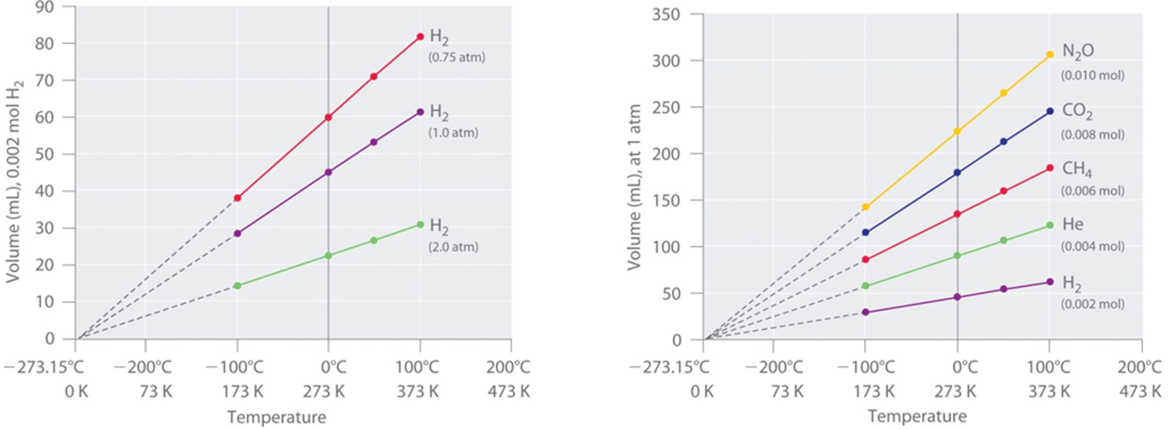

Boyle’s law: At **constant temperature**, the **volume** of a fixed quantity of gas **∝** .

Explained using kinetic theory: In a fixed quantity of gas at **constant temperature**, if you **increase the volume**, the **pressure will decrease** because the **gas particles have further to travel before hitting the container walls, decreasing the frequency of collisions**. The opposite is true if you decrease the volume.

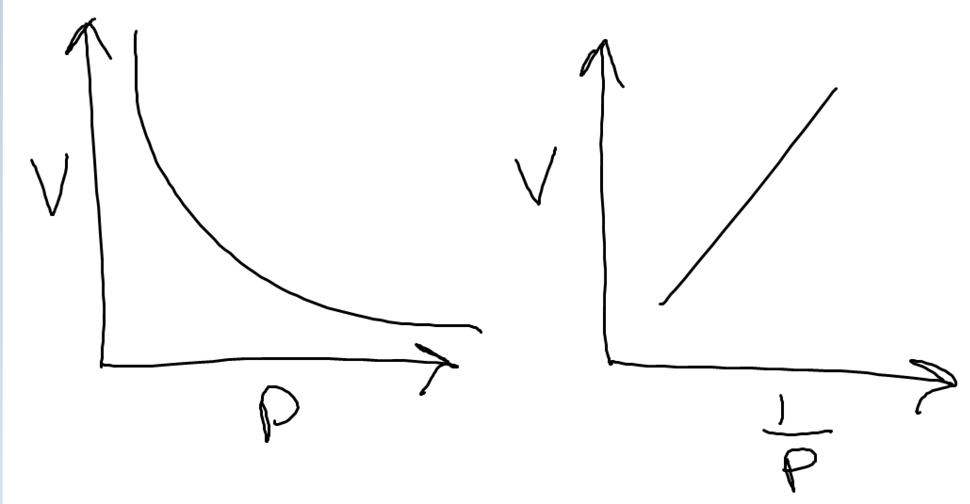

At **constant volume**, the **pressure** of a fixed quantity of gas **∝ temperature**.

Explained using kinetic theory: If the volume of a fixed quantity of gas is constant, as the **temperature is increased**, the **average kinetic energy of the particles increases**. This means the **velocity of the particles will increase** and they’ll **hit the walls of their container more often** and with **greater force** which **increases the pressure**.

If the **pressure and temperature are kept constant**, the **number of mols of gas ∝ volume**.

This is true because the **volume is dependent on the number of particles**, not the type of particles.

**n =**

Non-polar 🡪 Dispersion forces.

Polar 🡪 Dipole-dipole forces.

NOF + H 🡪 Hydrogen bonds.

Fully dissolve 🡪 Forces of solvent > forces of solute.

Not fully dissolve 🡪 Forces of solvent < forces of solute.

There are 2 reasons for the solute not dissolving:

1. Dispersion forces of solute > dispersion forces of solvent.
2. Molecular weight of solute > molecular weight of solvent.

Rf = =

Those with the higher affinity/polarity for water will travel further up the paper.

More similar bonds with the mobile phase 🡪 higher Rf value 🡪 higher affinity/polarity.

Dispersion forces < dipole-dipole forces < hydrogen bonding.

Dispersion forces:

* Are present between all molecules.
* Depend on molecular size and shape.
* Are the only forces between non-polar molecules.

Dipole-dipole forces are usually stronger than dispersion forces and are particularly significant in small polar molecules.

Hydrogen bonding is the strongest of the forces but is weak compared to covalent bonding.

For a solute to dissolve in a solvent, there must exist a significant force of attraction between the solute and solvent particles which must overcome the force of attraction between the solute-solute and solvent-solvent particles.

Polar solvents will dissolve polar solutes.

Non-polar solvents will dissolve non-polar solutes.

|  |  |
| --- | --- |
| **Substance type**: | **General trend in solubility in water**: |
| Metallic | Insoluble |
| Covalent network | Insoluble |
| Ionic | Many are soluble |
| Covalent molecular | Polar molecules tend to be soluble and  non-polar molecules tend to be insoluble |

For any liquid, a percentage of molecules that reach the surface of the liquid have sufficient kinetic energy to leave the liquid and form a vapour. The greater the number of particles escaping, the greater the vapour pressure.

The vapour pressure is dependent on the temperature of the liquid. The vapour pressure of one covalent molecular substance compared to another, at a set temperature, is dependent on the intermolecular forces exhibited.

There are 3 parts to any analysis involving chromatography:

* **Mixture**: Contains elements/compounds to be separated.
* **Stationary phase**: Mixture is placed onto the stationary phase. Components in the mixture are attracted to stationary phase to varying degrees because of intermolecular forces involved.
* **Mobile phase**: A specially selected solvent that’ll travel through the stationary phase. The strength of intermolecular forces between components in the mixture and the mobile phase determines how far and how rapidly the components in the mixture will move away from their original position.

There are 5 key components of a gas chromatograph:

1. **Carrier gas**: Very pure H2, He, N2 or Ar.
2. **Sample insertion**: Very small samples of mixture to be analysed injected into carrier gas.
3. **Stationary phase**: A column or coil containing the stationary phase which is a very viscous liquid e.g., methyl silicone. Separates gas components by virtue of solubility or boiling point and affinity of components for the molecules in the stationary phase.
4. **Detectors and computer integrators**: To analyse data, position and height of peaks compared to reference data to identify compounds and give relative (percentage) composition.

Chromatography:

* Separation technique based on intermolecular forces.
* Always makes use of mobile phase and stationary phase.
* Individual analytes in the mixture repeatedly adsorb to, and desorb from, the stationary phase.
* The more time an analyte spends adsorbed to the stationary phase, the less far/slower it travels.
* Analytes spend more time adsorbed to the stationary phase if their intermolecular forces are more similar to those of the stationary phase than those of the mobile phase.

Paper/Thin Layer Chromatography:

* Qualitative.
* Analytes can be identified by comparing retardation factors to known standards.

Rf =

Gas/High Performance Liquid Chromatography:

* Quantitative.
* Analytes can be identified by comparing retention factors to known standards.

Rf =

* Concentration of analytes can be determined by comparison of area under the peak to known standards.

**Q: Both CO2 and H2O consist of molecules with 2 atoms bonded to a central atom yet their shapes are different. Explain why this should occur.**

The shape of a molecule results from the **repulsion between groups of electrons** (both bonding and non-bonding) in the valence shell of the central atom in a molecule. The central atom of a CO2 is carbon and it has 2 groups of bonding electrons. The **optimum shape for this is linear** as it allows the **maximum angular separation of the 2 groups of bonding electrons** in the valence shell of the carbon atom.

The central atom of a H2O molecule is oxygen and it has 4 groups of electrons – 2 groups of bonding electrons and 2 lone pairs. The **optimum shape for this configuration is bent**. This shape allows the **maximum angular separation** of the 4 groups of electrons in the valence shell of the oxygen atom.

**Q: The covalent bond between hydrogen and fluorine in hydrogen fluorine (HF) is said to have a bond dipole whereas the covalent bond between fluorine atoms in fluorine gas has no bond dipole. Show your understanding of bond dipoles and how they occur.**

If 2 atoms of **different electronegativity** form a covalent bond, an uneven sharing of the bonding electrons will occur. The more electronegative atom attracts the electrons more strongly and gains a small negative charge and the less electronegative atom gains a small positive charge. This happens because the bonding electrons spend more time near the more electronegative element. Covalent bonds like this are said to have a bond dipole.

In HF the single covalent bond has a bond dipole as fluorine is more electronegative than hydrogen. Thus, the fluorine end of the bond has a slight negative charge and the hydrogen end a slight positive charge.

In F2 the single covalent bond has a zero bond dipole as both fluorine atoms have the same electronegativity. The shared pair of electrons in the covalent bond is on average midway between the 2 bonded fluorine atoms.

**Q: Galactose and glucose are both solid sugars. Galactose has a melting point 167°C while glucose has a melting point of 146°C. What do the different melting points indicate about the relative strength of the intermolecular forces in galactose compared to those in glucose?**

When a molecular substance like galactose or glucose melts, the **intermolecular forces** between the molecules have been **partially overcome**. This allows the molecules to **move freely amongst one another** in the liquid phase. A high melting point indicates the **molecules need a high kinetic energy** in order to **partially overcome** their mutual attraction (**intermolecular forces**) and change the solid phase to the liquid phase. Thus, the intermolecular forces in galactose are **stronger** than that in glucose.

**Q: Explain the formation of dipole-dipole forces in molecular compounds using hydrogen sulfide as an example (H2S).**

The H2S molecule is polar and thus has an uneven distribution of charge. In these molecules the hydrogen atoms have a slight positive charge while the sulfur atoms have a slight negative charge. Adjacent molecules in a sample of H2S will **attract weakly** by **aligning the opposite charges of their dipoles**.

**Q: Describe the origin of dispersion forces.**

Dispersion forces originate from the **random motion of electrons** within a molecule. This random electron motion produces **temporary dipoles** within the molecule. This effect **induces similar dipoles** in nearby molecules (**induced dipoles**). The molecule with the temporary dipole and the one with the induced dipole then experience **overall weak electrostatic attraction** known as **dispersion forces**. These attractive forces are in a state of **rapid change** as the temporary and induced dipoles constantly form, rapidly disappear and then reform once again. As dispersion forces are due to the random motion of electrons, then the **strength of this force increases as the number of electrons** in the molecule **increases**.

**Choose the substance from each pair that you’d expect to have the higher boiling point. Justify your answer.**

**[a] F2 and Cl2.**

Cl2 has a **greater number of electrons** so its **dispersion forces are stronger** than those in F2. Therefore, Cl2 has the higher boiling point.

**[b] CH3OCH3 and CH3CH2OH.**

Both molecules have similar dispersion forces but ethanol has the **ability to hydrogen bond** and so will have the higher boiling point.

**[c] CH4 and C4H10.**

C4H10 has a **greater number of molecular electrons** so its **dispersion forces are stronger** than those in CH4. Therefore, C4H10 has the higher boiling point.

**A student has a choice of 2 liquids: water (H2O) or decane (C10H22, a typical component found in the household solvent mineral turpentine). Choose the most suitable solvent for each substance and justify your choice in terms of intermolecular forces and polarity.**

**[a] Glycerol (CH2OHCHOHCH2OH).**

Glycerol molecules are **polar and can hydrogen bond**. Hence glycerol molecules attract strongly by **hydrogen bonding or dipole-dipole forces** (**solute-solute**). Water molecules are also **polar and can attract by hydrogen bonding or dipole-dipole forces** (**solvent-solvent**). Thus, water is the best solvent for glycerol as water molecules and glycerol molecules will be able to **mix and attract one another by similar intermolecular forces** (**solute-solvent**) because the solute-solvent intermolecular forces are of similar strength to (or stronger than) the solute-solute intermolecular forces and solvent-solvent intermolecular forces..

**[b] Petrol (essentially C8H18).**

Octane molecules attract other octane molecules by **dispersion forces** only (**solute-solute**). Decane molecules also attract one another by **dispersion forces** only (**solvent-solvent**). For this reason, decane would be the best solvent for octane as the 2 types of molecules can attract one another by **dispersion forces** (**solute-solvent**) and therefore the 2 substances will readily mix to form a solution because the solute-solvent intermolecular forces are of similar strength to (or stronger than) the solute-solute intermolecular forces and solvent-solvent intermolecular forces.

**[c] Diesel fuel, a mixture of hydrocarbons containing components like CH3(CH2)15CH3.**

Diesel fuel is a mixture of non-polar compounds hence the molecules in this mixture attract one another only by dispersion forces. Decane is also non-polar and its molecules are able to attract by dispersion forces only. For this reason, decane would be the best solvent for diesel fuel as the molecules in the 2 different substances can attract one another by dispersion forces and so will readily mix to form a solution.

[d] The monosaccharide glucose (C6H12O6).

Glucose molecules are polar and can hydrogen bond. Hence glucose molecules attract strongly by hydrogen bonding and dipole-dipole forces. Water molecules are also polar and can attract by hydrogen bonding and dipole-dipole forces. Thus, water is the best solvent for glucose as water molecules and glucose molecules will be able to mix and attract one another either by dipole-dipole forces or by hydrogen bonding.

Q: An essential property of proteins is their ability to form hydrogen bonds between various parts of the molecule. Among other things this allows some proteins to form a regular spiral structure known as the α helical form.

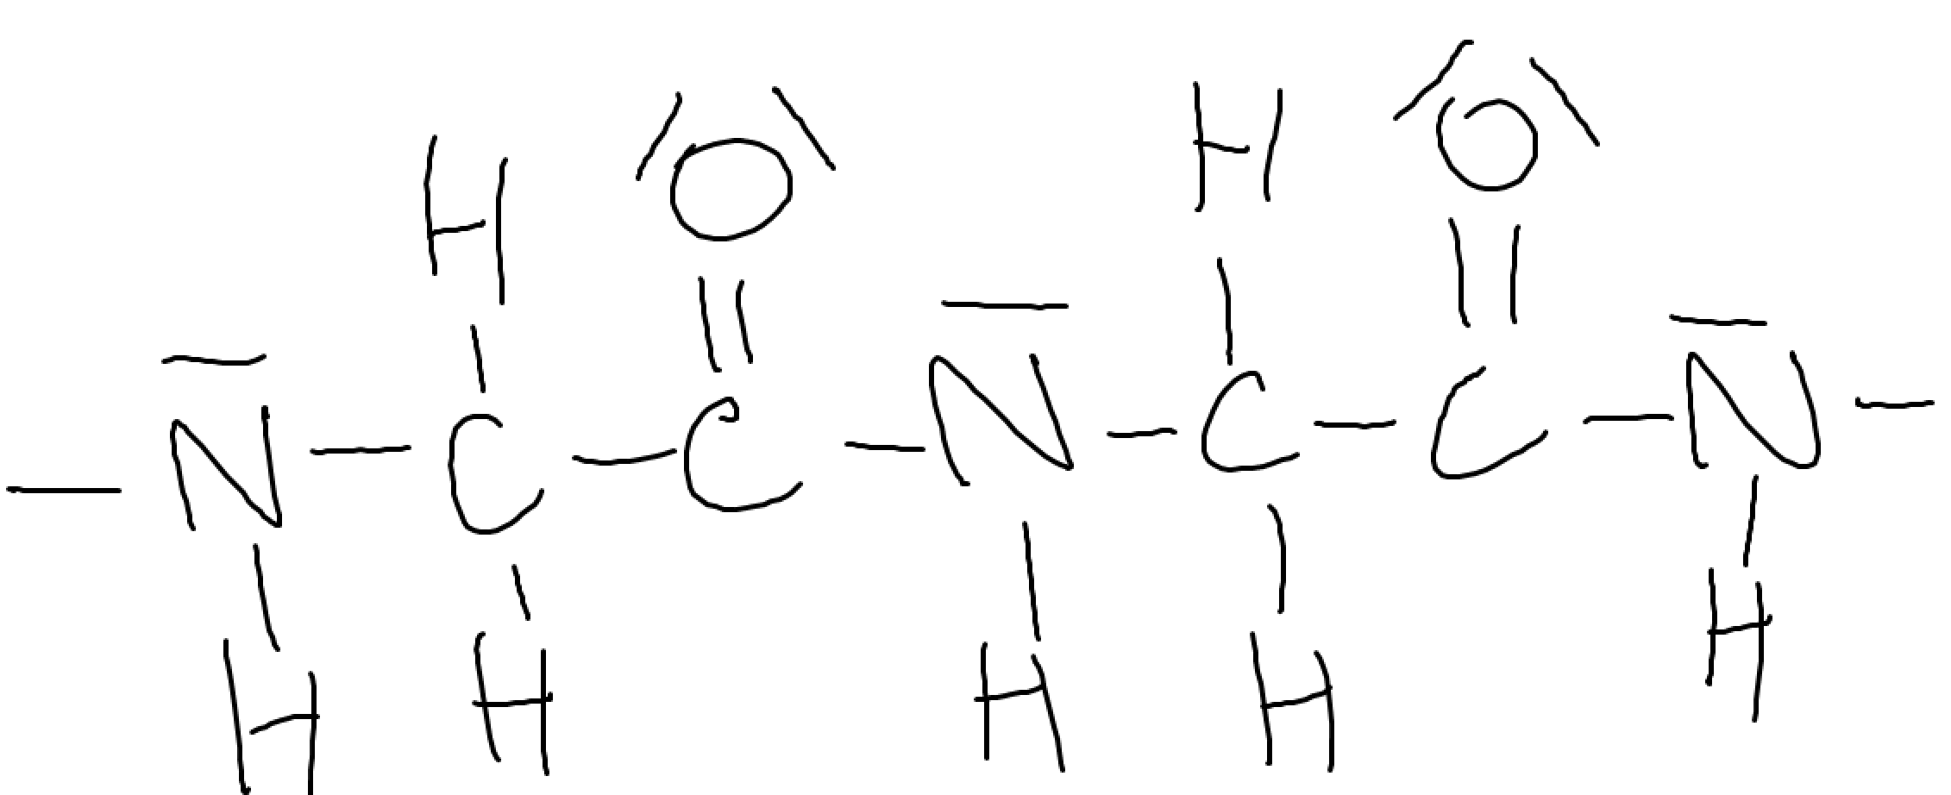

[a] What’s unique about the hydrogen atoms in proteins that allows them to be involved in hydrogen bonding?

These hydrogen atoms are covalently bonded to a nitrogen atom. The high electronegativity of the nitrogen atom results in a strong dipole with hydrogen. Consequently, the hydrogen atom has a strong positive charge. These hydrogen atoms can then interact quite strongly with the strong negative dipole and lone pair of a nitrogen or oxygen atom from the same molecule. This strong interaction is the basis of a hydrogen bonding in a protein molecule.

[b] Determine which lone pairs are actually involved in forming the hydrogen bonds responsible for the α helical structure of a protein molecule.

Lone pairs involved in hydrogen bonding are the ones from the oxygen atom.

With reference to strength and types of intermolecular forces, account for the difference in the boiling points of the following pairs of compounds.

[a] Methanol (CH3OH), boiling point 65°C, and methane (CH4), boiling point –162°C.

The dispersion forces in methanol are slightly greater than those in methane as methanol has slightly more electrons per molecule than methane does. This difference is far too small to account for the great difference in boiling points. The presence of hydrogen bonding and its absence in methane is the main reason for the much higher boiling point of methanol.

[b] Methanol (CH3OH), boiling point 65°C, and octane (C8H18), boiling point 126°C.

Strength of dispersion forces increase with the number of molecular electrons. As octane is a significantly larger molecule, with a much greater number of electrons per molecular than methanol, the dispersion forces in octane are much greater than those in methanol. This difference explains the higher boiling point of octane. This occurs despite the presence of strong hydrogen bonding amongst the much smaller methanol molecules.

**Q: The solubility of alcohols in water varies with the molar mass of the alcohol.**

**[a] Suggest a reason why alcohols like methanol would be expected to be very soluble in solvents like water.**

Alcohols like methanol are polar and can hydrogen bond as each methanol molecules contains one OH– group. Hence methanol molecules attract most strongly by hydrogen bonding. Water molecules are also polar and attract most strongly by hydrogen bonding. Thus, water is a good solvent for methanol as water molecules and methanol molecules will be able to mix and attract one another strongly by hydrogen bonding with each other.

**[b] How does the solubility of the listed alcohols vary with increasing molar mass?**

Solubility decreases with increasing molar mass.

**[c] Suggest an explanation for the trend you outlined in part (b) above.**

As the molar mass of the alcohols increases so does its molecular size and hence the number of electrons per molecule also increases. This increase in molecular electrons means a corresponding increase in the size of the dispersion forces between the alcohol molecules. For larger alcohol molecules, the **strength of the dispersion forces (solute-solute)** is so great it **far exceeds the strength of any hydrogen bonding (solute-solvent) that could possibly form with water molecules**. As a result, the **larger alcohol molecules don’t mix and hydrogen bond with the water molecules**. Instead, the higher molar mass alcohols remain **undissolved as a separate layer**, where the **alcohol molecules strongly attract one another by dispersion forces**.

**Q: Explain in terms of intermolecular forces why liquids have a surface tension.**

The surface tension of a liquid is a result of its intermolecular forces. At the surface of a liquid, there’s an imbalance of these forces causing surface molecules to be pulled inwards towards the bulk of the liquid. Consequently, the surface is trying to contract to achieve a minimum area. This puts the surface in compression and gives rise to surface tension. Usually, the stronger the intermolecular forces, the greater the resulting surface tension.

Q: How would the surface tension of benzene compare to that of water? Explain.

The surface tension of a non-polar benzene would be less than that of water. Surface tension is a consequence of an imbalance in intermolecular forces occurring at the surface of a liquid. Generally, the stronger the intermolecular forces, the greater the resulting surface tension.

Q: Detergents improve the ability of water to wet a surface. How must this affect its surface tension?

Since the detergents improve wetting ability, they must reduce surface tension.

Q: Describe what’s meant by the statement “water molecules are polar”.

Polar molecules have an uneven distribution of charge. These molecules have slightly positively charged regions and slightly negatively charged regions. In water molecules, the oxygen atom has a slight negative charge while each of the hydrogen atoms has a slight positive charge.

Postulates which are false with real gases:

Gas particles occupy volume which is insignificant when compared to the volume of the gas itself.

Gases have negligible forces of attraction or repulsion between them.